

ISTANBUL AYDIN UNIVERSITY

Hotel Management

**Öğr. Gör. PINAR KARADAYI ATAŞ**

SAMAH AYDIN

B1605.090076

1. **Introduction:**
   1. **Purpose of this document:**

A Hotel management system is a computerized management system. This system keeps the records of hardware assets besides software of this organization. The proposed system will keep a track of Workers, Recidents, Accounts and generation of report regarding the present status. This project has GUI based software that will help in storing, updating and retrieving the information through various user-friendly menu-driven modules.The project “Hotel Management System” is aimed to develop to maintain the day-to-day state of admission/Vacation of Recidents, List of Workers , payment details etc. Main objective of this project is to provide solution for hotel to manage most there work using computerized process. This software application will help admin to handle customers information, room allocation details, payment details, billing information.etc. Detailed explanation about modules and design are provided in project documentation. The existing system is a manually maintained system. All the Hotel records are to be maintained for the details of each customers, Fee details, Room Allocation , Attendance etc. All these details are entered and retrieved manually,because of this there are many disadvantages like Time Consuming ,updating process, inaccuracy of data.For avoiding this we introduced or proposed a new system in proposed system the computerized version of the existing system. provides easy and quick access over the data.

1. **Scope:**

The scope of hotel management ranges from housekeeping and general cleaning to providing customer service. A manager is responsible for everything that happens in the hotel, so the scope for the job generally covers everything that goes on in the hotel.

1. **Background and Objectives:**

Hotel management system provides room booking, staff management and other necessary hotel management features. The system allows the manager to post available rooms in the system. Customers can view and book room online. Other hotel services can also be viewed by the customers and can book them too.

1. **Overall view:**

In this project, we have created 8 forms which each one of them show a specific thing. First form was login page which is connected to SQLite and which require name and password, so if the customer has an account before he can login easily, otherwise he will click register for registering for a new account which will require first name, last name, phone number and password. After clicking on the register button it will go to the login page. After logging in, an activity will appear which is kind of list activity that shows buttons for room booking and some other services for customers. First, Add Room button is for adding a customer information, these information which the customer added will appear on an activity. Second, Location button which will go to google map. Finally is the gallery button which will open an activity which has some pictures about some hotel rooms. And a button for logging out which will go to the main page which is login page.

1. **SQLite Connection:**

A SQLite java class was made and named as DatabaseH to connect the login and registration page into sqlite.

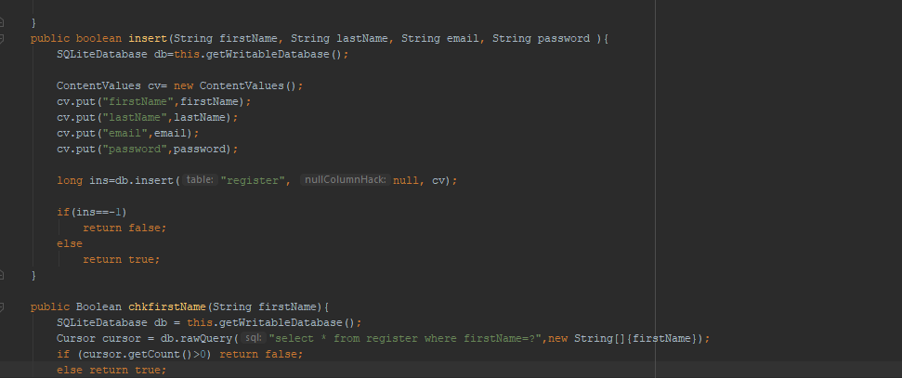

**Login page:**

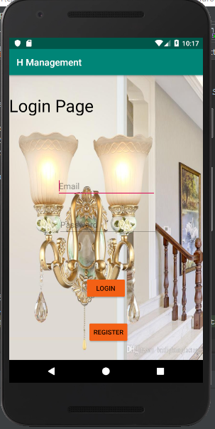

Which you can access to the hotel application.

**Registration Page:**

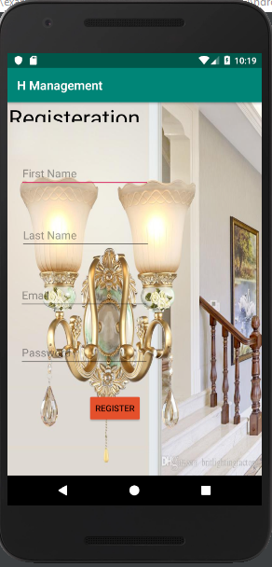

Registration page is for having an account in the hotel so you can login anytime the customer wants.

**Main Page (List):**

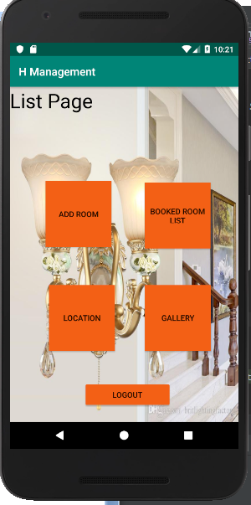

Here the customer can find the services that he want. And there is a logout button for logging out and going again to login page.

**Add Room Page:**

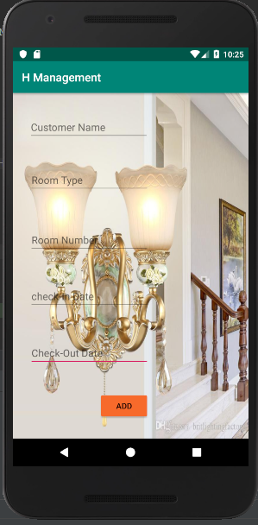

This page is for filling the customer information of a room, which contains customer name, room type, room number, room number, check-in date, check-out date and an add button for saving the information.

**Gallery Page:**

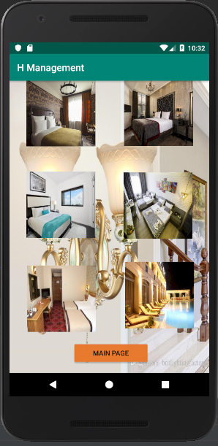

Here are some Pictures about what this hotel has.